Chapter 17, Problem 63.

Plot the amplitude spectrum for the signal f₂(t) in Fig. 17.56(b). Consider the first five terms.

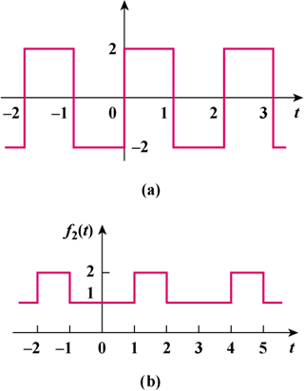

Figure 17.56
For Prob. 17.63.

